Lesson 8. The Olympics Games. Functions of an adjective in a sentence.

Warming up: Answer the questions:
- Do you go in for sports?
- What sport do you go in for?
- Do you like to play volley-ball (basket-ball, football, ice hockey, tennis,….)?
- Can you name some famous sportsmen and sportswomen of Ukraine?
- What are they famous for?
- Do you like to swim? Are you a good swimmer?
- Does sport help you to be in a good form?
Main Part
- Vocabulary
take place – відбуватися ancient – давній
honor – шанувати, удостоювати hold – проводити
motto – гасло, девіз represent – представляти
drug – стимулятори set up – організовувати
BC = before Christ – до Різдва Христова mankind – людство
AD = Anno Domini – у рік Господній to compete – змагатися
to award prizes – нагороджувати призами to glorify – прославляти
loser – переможений winner – переможець

- Reading. Exercise 1. Read and translate the text
The Olympic Games
The Olympic games have a very long history. They began in 777 BC in Greece and took place every four years for twelve centuries in Olympia. For the period of games all the wars stopped. So, the Olympic Games became the symbol of peace and friendship.
The games included many different kinds of sports, among them running, boxing and wrestling. All the cities in Greece sent their best athletes to the city of Olympia to compete in the games. Thousands of people from all parts of Greece came to see the games. In 394 AD all the games stopped.
In 1894, French baron Pierre de Coubertin addressed all countries, and said that sport was very important for the whole world. Two years later the first modern Olympic games took place. In 1896 the International Olympic Committee was set up.
The first of the modern series of Games took place in Athens in 1896 on the site where the ancient festivals had been held 1.500 years before. Since then, except in 1916, 1940 and 1944, the Olympic Games have been held every leap-year.
The Olympic idea means friendship, fraternity, and cooperation among the youth of the world. The best known symbol of the Olympic Movement is the five linked rings. The Olympic flag itself is white and the rings are in five colors: blue, yellow, black, green and red represent the nations of the world, since every national flag contains at least one of these colors.
The motto of the Games: ”Faster, higher, braver” put the emphasis on personal not team performance and achievement. Summer and Winter Games are held separately.
Exercise 2. Answer the questions:
- Where and when were the Olympic Games organized?
- What sports did they include?
- What is the Olympic motto?
- What do the Olympic games symbolize?
- Why are the Olympic Games important for the whole mankind?
Exercise 3. Fill in the gaps.
H_st_ry, Gr_ _ ce, p_ _ce, w_rld, m_d_rn, w_r, int_rn_tional.
Exercise 4. Unscramble the following words and translate them into Ukrainian.
BOSLYM –
DAFINERPIHS –
TATNIPOMR –
ANOLIRTANETIN –
Exercise 5. Choose the correct item.
- The Olympic Games began in
- China b) Egypt c) Greece
- They took place every ____ years.
- Four b) five c) six
- Sport is very important for _____
- Greece b) Europe c) the whole world
- In ____the International Committee was organized
- 1895 b) 1896 c) 1897
Exercise 6. Сorrect the information.
- The Olympic Game began in 780 BC in Rome.
_______________________________________
- They were held during eleven centuries.
________________________________________
- In 396 AD, the games stopped.
_________________________________________
- In 1894, a German person offered to continue the Olympic Games.
____________________________________________________________
- The first modern Olympic Games took place in 1895.
_____________________________________________________________
- Summer and Winter Games are held together.
_____________________________________________________________
Exercise 7. Choose the word which best matches the definition:
1. A long stick that one throws as far as possible.
a) javelin b) board c) track
2. An event when an athlete throws a heavy little metal ball as far as possible.
a) javelin b) shot put c) pole vault
3. A boxer has to wear these during a boxing match.
a) gloves b) mittens c) elbow-pads
4. A tennis player can't play without one of these.
a) racket b) racquet c) cricket
5. What does a basketball player do to score points?
a) He throws the ball
b) He launches the ball
c) He shoots the ball
6. What do fencers use?
a) sticks
b) javelins
c) swords
7. The Romanian gymnast performed a very ________________( = hard) routine.
a) difficult
b) different
c) diverse
8. A baseball player uses this to swing at a ball.
a) helmet
b) bat
c) base
9. The biathlon ________________ three different sports - swimming, biking, and running.
a) consists of
b) combines
c) A or B
10. Without this, you can't make a canoe go faster.
a) paddle
b) board
c) stick
III) Grammar explanation. Functions of an adjective in a sentence.

An adjective is a word that has the semantic role of providing further information about a noun’s quality or state of being (such as its size, quantity or material) and the syntactic role of pre- or post-modifying nouns and noun phrases within a clause.
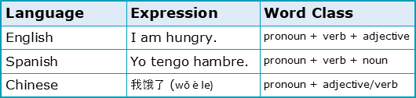
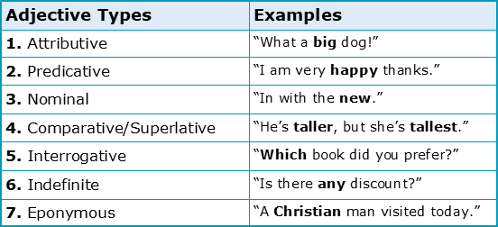
How are adjectives useful in English?
By answering questions such as ‘whose?’, ‘what kind?’ or ‘which one?’, adjectives in the English language are a particularly useful word class. To summarise their usefulness, we’ve identified an adjective’s six common functions below:

Function 1: Adjectives describe nouns
Firstly, and most importantly, whether you wish to describe an object’s number, quality, size, age, shape, colour, origin or material, there are simply hundreds (if not thousands) of adjectives that can help:
Function 2: Adjectives can provide specific opinions
Additionally, some adjectives may be used to provide specific opinions about specific types of nouns, restricting the overall number of nouns they can modify but increasing their descriptive power. When describing foods for example, the use of adjectives such as ‘delicious’ or ‘tasty’ would be quite grammatical, whereas the use of ‘pretty’ to describe a man and ‘handsome’ to describe a women would be considered most often incorrect.

Function 3: Adjectives can provide general opinions
Conversely, and less useful to the academic, are the adjectives provided in the table below that are more generally descriptive. These adjectives allow for greater flexibility with regards to the nouns they can modify. General adjectives such as ‘beautiful’ or ‘strange’ are indeed applicable to a vast number of nouns, which may perhaps help to explain why they’re so commonly used in spoken English.
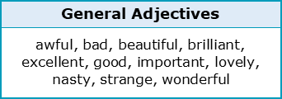
Function 4: Adjectives can form comparisons
As is discussed in some detail in our short reader on comparatives and superlatives, certain adjectives such as ‘tall’ or ‘fast’ allow for comparisons to be made about two or more things in English. Such comparisons are usually made by simply adding an ‘-er’ or ‘-est’ suffix to the end of each adjective:
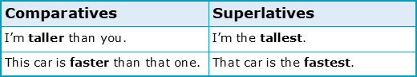
Function 5: Adjectives can intensify nouns
A fifth way that adjectives might be of use is when attempting to intensify a noun. Certain adjectives such as ‘absolute’ (as in ‘it was an absolute success’) are able to strengthen a noun in this way with ease. While the most common intensifying adjectives have been provided for you below, it’s worth noting that most of these are rather informal and should generally be avoided in academic contexts:
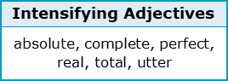
Function 6: Adjectives can mitigate nouns
Finally, and to the opposite effect, a small number of adjectives may also be used to weaken nouns through mitigation. To weaken how ‘boring’ a person is for example, perhaps to be polite, we could use the mitigating adjective ‘quite’ to create the expression ‘he is quite boring’.
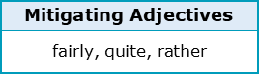
Now that we’ve discussed what an adjective is in the English language and how they’re most useful for users of general or academic English, Chapter 2 next focusses on discussing the best methods for identifying adjectives in context. Continue reading if you wish to know more.

Exercise 8. Choose the correct option to complete the sentences below (-ed/-ing adjectives – adjectives from verbs)
- I love skydiving. It's an amazed/amazing feeling.
- 2The robber was carrying a gun and wearing the mask of a clown. He was terrifying/terrified.
- She was very annoying/annoyed with him for not telling her the truth.
- 4The students are very disappointing/disappointed about the exam results.
- 5My teacher is very bored/boring. He speaks so slowly that we just want to sleep.
- This year, all the presents that I got for Christmas were very disappointed/disappointing.
- He's a very interesting/interested man. He's travelled all around the world.
- 8I was so surprised/surprising to see her. She wasn't supposed to be there.
- Teenagers get very embarrassing/embarrassed when they have to speak in public.
- 0In the photo you can see the shoking/shoked image of what seems to be a ghost.

Exercise 9. Choose the correct option for each gap below.
1) I am so ______! This massage chair is very ______.
a.relaxed / relaxing
b.relaxing / relaxed
c.relaxing / relaxing
2) I get very _____ when I can't find the words to say what I mean to say. It's so ______.
a.frustrated / frustrating
b.frustrating / frustrated
c.frustrated / frustrated
3) She knows a lot of ______ facts. She is very ______.
a.interesting / interested
b.interested / interesting
c.interesting / interesting
4) She is never ______ with her work. She should try to do something more ______.
a.satisfied / satisfied
b.satisfied / satisfying
c.satisfying / satisfied
5) The journey was very ______. We were very ______ when we arrived.
a.tired / tired
b.tired / tiring
c.tiring / tired

6) I find my parents very ______. They put me in a lot of ______ situations.
a.embarrassing / embarrassed
b.embarrassed / embarrassing
c.embarrassing / embarrassing
7) We were totally ______ by the ______ views.
a.amazed / amazed
b.amazed / amazing
c.amazing / amazing
8) The truth is that it's a very ______ situation. You should be ______.
a.worried / worried
b.worried / worrying
c.worrying / worried
9) I'm always ______ on Monday mornings. They are so ______.
a.depressing / depressed
b.depressed / depressing
c.depressed / depressed
10) The teacher's instructions were very ______. All the students were really ______.
a.confusing / confused
b.confusing / confusing
c.confused / confusing

Exercise 10. Fill in the gaps by turing the verbs in brackets into ed/-ing adjectives.
Початок форми
When I finish work, I'm usually (exhaust) because my job is very (tire). Every day at 6 p.m. I just want to go home, and have a (relax) bath. I love having a bath after work! In the bath I feel very (relax) and I forget about how bore) my job is.
But I'm retiring next month! So I will not have to worry about my job any more. I am so (excite)! Also, I will never have to talk to my boss any more. He is so (irritate)!
Some people think retirement is a bit (frighten). They say they don't know what they will do after they retire, and they are sometimes scared. I don't understand these people. I think when I retire, I'll never be (bore); I will always have some (entertain) activity to do.
Кінець форми

Homework assignment: learn vocabulary, ex.7,10 write down.

