МІНІСТЕРСТВО ОСВІТИ І НАУКИ УКРАЇНИ
ІНОЗЕМНА МОВА
Методичні вказівки до виконання практичних робіт
для здобувачів початкового рівня ( короткий цикл) вищої освіти
Освітньо-професійна програма «Менеджмент»
Галузь знань 07 Управління та адміністрування
Спеціальність 073 Менеджмент
денної форми навчання

ЛУЦЬК 2019
УДК 811.111:004
І - 57
До друку
Голова навчально-методичної ради Луцького НТУ __________ В.І. Талах

Електронна копія друкованого видання передана для внесення в репозитарій Луцького НТУ
Директор бібліотеки ________________ С.С. Бакуменко

Затверджено навчально-методичною радою Луцького НТУ,
протокол №___ від «____» ___________ 2019 року

Рекомендовано до видання навчально-методичною радою ТК Луцького НТУ, протокол № ___ від «____» ___________ 2019 року
Голова навчально-методичної ради ТК ЛНТУ ___________ Т.П. Радіщук

Розглянуто і схвалено на засіданні циклової комісії словесних і суспільних дисциплін ТК Луцького НТУ,
протокол №______ від «____»________2019 року.
Голова ЦК ____________________ В.П. Cафатюк

Укладач: ________________ І.М. Лавринюк, викладач Технічного коледжу Луцького НТУ

Рецензент: ___________ Н.А.Одарчук, кандидат філологічних наук, доцент кафедри практики англійської мови Східноєвропейського національного університету імені Лесі Українки

Відповідальний за випуск: ______________В.П. Сафатюк, голова ЦК словесних і суспільних дисциплін Технічного коледжу Луцького НТУ

Іноземна мова: методичні вказівки до виконання практичних
робіт для здобувачів вищої освіти освітньо-професійної програми
І-57 «Менеджмент»,галузі знань 07 Управління та адміністрування,
спеціальності 073 Менеджмент, денної форми навчання / уклад.
І.М. Лавринюк– Луцьк: ТК Луцького НТУ, 2019.– 54 с.

Методичне видання складене відповідно до робочої програми курсу «Іноземна мова» для здобувачів вищої освіти початкового рівня (короткий цикл) з метою визначення завдань практичної роботи студентів та надання методичної допомоги у процесі їх виконання.

© І.М.Лавринюк, 2019

ЗМІСТ
ВСТУП…….……………………………………………………………………….4
PRACTICAL WORK 1. THE WORLD OF ART………………….……………...6
PRACTICAL WORK 2.VISUAL ART……………………………….………….10
PRACTICAL WORK 3. CINEMA/ MOVIE…………..…………..………..……13
PRACTICAL WORK 4. PAINTING………………………….………...…..……24
PRACTICAL WORK5.PERFORMING ART……………...........................….…32
PRACTICAL WORK 6.THEATRE……………….……………………….…….35
PRACTICAL WORK 7.MUSIC………………………..………….………..……37
PRACTICAL WORK 8. STREET ART………………………….………………47
PRACTICAL WORK 9. WRITTEN ART………………………………….…….49
СПИСОК ВИКОРИСТАНИХ ДЖЕРЕЛ………………….……...…………….54

ВСТУП
Оновлення мовної освіти потребує новітніх технологій навчання іноземних мов, розробки інноваційних методик, спрямованих на формування мовної особистості.
Дані методичні вказівки містять нові методи навчання - колективне, групове, навчання у співпраці, де і студент і викладач є рівноправним суб’єктом навчання. Розв’язання певного виду завдань, що передбачає належний рівень сформованості професійно зумовленого мовлення, є важливою складовою підготовки спеціалістів усіх напрямків. Cтуденти повинні володіти мовним матеріалом та засобами мови, якою вони спілкуються, оскільки за допомогою них можна побудувати і сформулювати значущі висловлювання, вміло їх використовувати. Йдеться про знання мови на фонологічному, семантичному (лексичному і граматичному) і структурно-синтаксичному рівнях.
Метою навчально-методичних вказівок є:
1) систематизація та розширення словникового запасу студентів з професійних тем спрямування;
2) навчання студентів правильно вживати вивчені лексичні одиниці в усному мовленні;
3) розвиток логічного, аналітичного мислення, оволодіння певною термінологією професійного спрямування та застосовування її на практиці, розширення світогляду студентів;
4) розвиток уваги, пам’яті, уяви, здогадки;
5) виховання особистості та розвиток її соціокультурної компетенції.
Дані вказівки складаються з розділів, кожен з яких містить тексти і контролюючі завдання, які можуть бути використані для перевірки знань студентів.
Вказівки призначені для здобувачів вищої освіти спеціальності “Менеджмент”.

Performing art

Written art

Museums
and Theatres

Visual art

Paintings

Practical work 1. The world of art
Genre -жанр
Image – знак
Fame- слава
An artist- художник
Masterpiece – шедевр
Scene - сцена
Tendency- тенденція
Theme- тема
To depict – змальовувати
To devote – присвячувати
To be influenced by – бути під впливом
DIFFERENT TYPES OF ART
There are many different types of arts in the world. The most popular ones are cinema, theater, literature, music and painting. I’d like to tell you a little bit about each of these arts. First of all, my favourite type of art is music. It has always fascinated me how people create such melodic tunes. I love all genres of music, be it jazz, classical, pop, rock, reggae, opera, blues or else. Music can change my mood. If I’m sad I try to listen to something cheerful, for example, to disco music. If I want to think in loneliness, I prefer alternative rock. I’m glad that there are so many devices nowadays which allow us to listen to music everywhere we wish.
It includes radios, MP-3 players, CD-players, mobile phones. My second favourite type of art is literature. I like reading interesting novels and detective stories. I also value the works of famous writers and poets. Speaking of Russian writers I’ve read some works of Pushkin, Lermontov, Tolstoy, Turgenev, Dostoevsky and Mayakovski. Their works are world-famous and many books have been translated into other languages. Theater is gradually becoming an outdated type of art. On the contrary, cinemas become more popular. There are many great theatres and large cinemas in Russia. I think people should respect the work of actors and attend theatres more often. As for me, I don’t really like cinemas. If I want to watch a new movie, I buy and watch it at home.
Painting is another form of art. Museums and art galleries have always attracted me. I think that painting is a rather interesting activity. One of my friends is really good at it. He is going to enter the University of Arts after graduating from school. His works include oil paintings and pastel. I really admire his talent. I wish I could be as good at painting as him. All artists try to express their feelings and emotions in their paintings. The most common definition of painting is the art of portraying and representing objects with line and colour. The first ones were the depictions of animals. The oldest knowing paintings can be found in France at the Chauvet Cave. Some historians claim that they are about 32, 000 years old. They represent engraved paintings with red ochre and black pigment. The pictures of horses, rhinoceros, lions, and buffalo are shown there. The examples of cave paintings can be also found in other countries, including India, Spain, Australia, and China. While painting, artists use different types of paint. For example, many artists prefer oil painting. Others choose to use pastel or watercolor, gouache or enamel. All techniques are attractive in their own way. Styles of painting also differ. They have changed over the centuries. Some of the latest styles are modernism, impressionism and abstract expressionism. I’m a real art lover and when I get a spare time, I try to visit an art gallery or a museum. I have already visited the Pushkin Museum of Fine Arts and the Tretyakov Gallery. However
However, when I have a chance I’ll go there again. These museums are huge and contain a large collection of art works by Russian and western painters. Apart from that, I have visited the Museum of Nikolay Roerich. I found many unusual and abstract paintings there, which I absolutely loved.

Fill the gaps:
- The most popular genres of art……
- Devices nowadays which allow us to listen to music everywhere we wish…..
- If I’m sad I try to listen to something……
- Russian writers…..
- The most common definition of painting…..
- Many artists prefer oil painting, …..
- Theater is gradually becoming an outdated type of art. On the contrary, cinemas
- Some of the latest styles are….
- ….museums are huge and contain a large collection of art works by Russian and western painters
- Apart from that, I have visited the……
Complete the text with the words below:
Masterpiece, contains, exhibits, piece, collection, paintings, icons
Museum of Art was founded in 1919 on the basis of the private….of Kyiv archaeologist Bohdan Khanenko. The Green Cabinet features the collection of Medieval Art, the Golden Cabinet ….objects of Rococo epoch and in the Red Cabinet you can find …. of Renaissance period. There are 17 000 ….in the museum funds. Among the exhibits are the paintings of Bellini. Hals. Reynolds. Rubens, …. 'Infant Margaret’ by Velazquez and unique Byzantine / Sinai …..of the 6-7th centuries written by wax paint. Interesting exhibits are presented at the Department of Oriental Art: … of Coptic fabric with the picture of horseman (5-6 centuries), ritual Chinese bell (1st century BC), excellent Chinese paintings on the scrolls (15-20th centuries) and Japanese paintings.

Practical work 2. Visual art

Ceramics- Гончарство
Drawing-Малювання Олівцем
Painting- Малювання Фарбами
Sculpture – Скульптура
Printmaking- Художній Друк
Design- Дизайн
Crafts- Ремесла
Photography – Фотографія
Video – Відео
Film-Making – Фільмографія
Architecture- Архітектура
Тalk with your partner:
- What is the difference between drawing and painting?
- What are the subject of your favourite pictures?
- What is your favourite painting?
- Who is your favourite painter?
Listen the text and fill in the sentences
I’m a ______________________ . I look at beautiful paintings and sculptures and wish I could be artistic. I can’t draw or paint ______________________ life. I wonder why some people are so talented and can create ______________________ , when other people, like me, can’t even draw good ______________________ . I would like to fill my house ______________________ all over the world. It’s interesting to see how different cultures have different ______________________ . There’s nothing better than visiting ________.
Last year, I visit ________ at London. Really, I was impressed by ________.
Leonardo di ser Piero da Vinci
Leonardo, was an Italian polymath of the Renaissance whose areas of interest included invention, drawing, painting, sculpting, architecture, science, music, mathematics, engineering, literature, anatomy, geology, astronomy, botany, writing, history, and cartography. He has been variously called the father of palaeontology, ichnology, and architecture, and he is widely considered one of the greatest painters of all time. Sometimes credited with the inventions of the parachute, helicopter, and tank, he epitomised the Renaissance humanist ideal.
Many historians and scholars regard Leonardo as the prime exemplar of the "Universal Genius" or "Renaissance Man", an individual of "unquenchable curiosity" and "feverishly inventive imagination" and he is widely considered one of the most diversely talented individuals ever to have lived.] According to art historian Helen Gardner, the scope and depth of his interests were without precedent in recorded history, and "his mind and personality seem to us superhuman, while the man himself mysterious and remote".Marco Rosci notes that, while there is much speculation regarding his life and personality, his view of the world was logical rather than mysterious, although the empirical methods he employed were unorthodox for his time.
Leonardo was born out of wedlock to notary Piero da Vinci and a peasant woman named Caterina in Vinci in the region of Florence, and he was educated in the studio of Florentine painter Andrea del Verrocchio. Much of his earlier working life was spent in the service of Ludovico il Moro in Milan. He later worked in Rome, Bologna, and Venice, and he spent his last years in France at the home awarded to him by Francis I of France.
Leonardo is renowned primarily as a painter. The Mona Lisa is the most famous of his works and the most parodied portrait, and The Last Supper is the most reproduced religious painting of all timeHis drawing of the Vitruvian Man is also regarded as a cultural icon being reproduced on items as varied as the euro coin, textbooks, and T-shirts. His painting Salvator Mundi sold for $450.3 million at a Christie's auction in New York on 15 November 2017, the highest price ever paid for a work of art.Perhaps 15 of his paintings have survived Nevertheless, these few works compose a contribution to later generations of artists rivalled only by that of his contemporary Michelangelo, together with his notebooks, which contain drawings, scientific diagrams, and his thoughts on the nature of painting.
Leonardo is revered for his technological ingenuity. He conceptualised flying machines, a type of armoured fighting vehicle, concentrated solar power, an adding machine, and the double hull. Relatively few of his designs were constructed or even feasible during his lifetime, as the modern scientific approaches to metallurgy and engineering were only in their infancy during the Renaissance. Some of his smaller inventions, however, entered the world of manufacturing unheralded, such as an automated bobbin winder and a machine for testing the tensile strength of wire. A number of his most practical inventions are displayed as working models at the Museum of Vinci. He made substantial discoveries in anatomy, civil engineering, geology, optics, and hydrodynamics, but he did not publish his findings and they had no direct influence on later science.

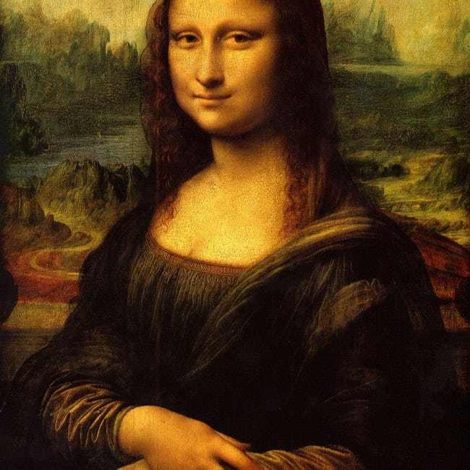
Writing:
- Explain your impression of this masterpiece.
Practical work 3. Cinema/ movie
Genres of cinema- жанри кіно
Feature films- фантастика
Love story- любовні
Science films- наукові
Detectives- детективи
Cartoons- мультики
Leading part- головна роль
Star-зірка кіно
Screen version-екранний режим
Horror – жахи
Melodrama- мелодрама
Comedy-комедія
.. СINEMА
In England the cinema is usually called "the pictures". In America the word "the movies" is often used. Cinema-going is a favourite pastime in Britain. People go to the cinema once or twice a week. Cinema-going is more popular in industrial towns in the North of England and Scotland than in the South. However, especially if it is cold and wet outside, many people like to stay at home to watch TVCinemas in England are usually large and more comfortable than the theatres.
Often there is a restaurant, so that it is possible to spend an afternoon and evening there (if you have enough money, of course). Behind the cine-ma screen there is a stage, so that the building can be used for concerts and other performances.British cinema-goers see mainly English and American films, though many of the foreign films are often shown in London and in the South of the country.In our country cinema-going is not so popular now as it was earlier. People prefer to stay at home and to watch TV or video.
І like to watch films very much. I prefer thrillers, comedies and horror movies, but I do not like tragedies and melodramas very much, and I hate soap operas, although they are becoming very popular in our country. My favourite film is ... with ... starring. It is really wonderful from the beginning to the end. There are a lot of films which are worth seeing, but this one is the best one to my mind.
. THE BEST FILM I HAVE EVER SEEN – TITANIC
As you know, the 3-hour-14-minute film "Titanic" is no mere disaster movie. It's an epic love story about a 17-year-old American aristocrat who is betrothed to a rich and hateful suitor but falls in love with a free-spirited artist, who won his third-class passage in a card game. It's "Romeo and Juliet" on a sinking ship and has become an international sensation."Titanic" is also a movie about money and its evils. With fine irony, Cameron has spent more dollars than any other filmmaker to make a film that denounces the rich. The $8,4 million costume budget alone would finance several independent movies. Production designer Peter Lamont copied the real Titanic down to the exact shade of green on the chairs in the smoking lounge. The sumptuous sets have made-to-order replicas of the china, the stained-glass windows - and since all of it was going to be destroyed, nothing could be rented. "To the best of our knowledge, there was no violation of historical truth", says Cameron. "We have a great responsibility. Whatever we make, will become the truth, the visual reality that a generation will accept", says Cameron.
The special effects are in the service of the story. In the 80-minute sinking of the ship, you don't wonder what's real and what's computer-generated. What you feel is the horror of the experience, the depths of the folly that left this "unsinkable" ship so vulnerable to disaster. While the women and children are loaded into lifeboats (there were only enough for half the 2,200 passengers), the third-class passengers are locked.
Cameron makes terrifying poetry out of chaos with images of the ship breaking in half, the deck rising perpendicular to the water as passengers bounce off the ships's giant propellers into the freezing ocean.
But it is the love between the unhappy Rose and the sanguine, openhearted Jack that occupies stage center. Is it the great love story Cameron so desperately wanted to make? Not quite. Visually, his lovers are an odd match: next to DiCaprio's boyish beauty, Kate Winslet looks womanly. And once the disaster strikes, their individual fates become overwhelmed by the communal horror. Our hearts, at least, couldn't but break once these lovestruck kids were surrounded by floating frozen corpses.
Listen the video:
І.Match the speaker to the genre of film. Write a–e next to the number
Speaker 1 a. A science fiction film
Speaker 2 b. A modern vampire film
Speaker 3 c. An action
Speaker 4 d. A romance
Speaker 5 e. A romance based on a book
II.Complete the gaps with the correct speaker.
A (x2) B C D (x2) E (x3)
1. Speaker _______________ thinks the film shows you not to judge people too quickly
2. Speaker _______________ says the film is not too sentimental, thanks to the actor.
3. Speaker _______________ likes a film in which everything we think is real is fiction.
4. Speaker _______________ has seen their favourite film more than once.
5. Speaker _______________ prefers the first version of the film.
6. Speaker _______________ likes a film with murder, violence and blood-drinking.
7. Speaker _______________ likes a film which tells a love story over several years.
8. Speaker _______________ likes a film which shows bullying at school.
9. Speaker _______________ likes the scenes filmed in different countries.

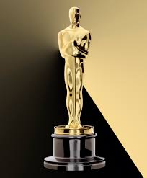 OSCAR
It is well-known that Oscars are awarded by the Academy of Motion Picture Arts and Sciences. It is a professional honorary organization composed of over 6,000 motion picture artists and craftsmen and women. The Academy was organized in May, 1927, as a nonprofit corporation chartered under the laws of California.
A popular story has been that an Academy librarian and eventual executive director, Margaret Herrick, thought the statuette resembled her Uncle Oscar and said so, and that as a result the Academy staff began referring to it as Oscar. No hard evidence exists to support that tale, but in any case, by the sixth Awards Presentation in 1934, Hollywood columnist Sidney Skolsky used the name in his column in reference to Katharine Hepburn's first Best Actress win. The Academy itself didn't use the nickname officially until 1939.
The Oscar is a tin and copper statuette of a naked man holding a sword and standing on a reel of film. The award weighs 8 1/2 pounds and is plated with gold. Since the list of winners is kept secret until the telecast, the awards handed out on television are blanks. The Academy reclaims the statuettes the morning after the telecast and has them engraved before they are shipped back to the anxious recipients. The personalized engraving is on a small plaque attached to the pedestal on which Oscar stands. The engraving includes the year, the award category and the name of the recipient. Each statuette is also engraved with a serial number on the back of its base.
Since its conception, the Oscar statuette has met exacting uniform standards - with a few notable exceptions. In the 1930s, juvenile players received miniature replicas of the statuette; ventriloquist Edgar Bergen was presented with a wooden statuette with a moveable mouth; and Walt Disney was honored with one full-size and seven miniature statuettes on behalf of his animated feature Snow White and the Seven Dwarfs. Between 1942 and 1944, in support of the war effort, Oscars were made of plaster. After the War, winners turned in the temporary awards for golden Oscar statuettes.
Watching the Oscar telecast has become the equivalent of a secular religious experience for many. The Oscars occur every year at the same time and there are strict rules and regulations and hundreds of commandments. The Oscar itself has become a sacred icon within the industry.
Answer:
- What is OSCAR?
- From which this statuette made?
- Which nomination include Oscar?
- Name the last star who had OSCAR?

Listen to the text "Art":
.Write true, false, doesn’t say:
1. The speaker is going to buy tow famous paintings.
2. The speaker would like to attend special art courses.
3. The speaker work in the art gallery.
FILMMAKING TECHNOLOGY
A film, also called a movie or motion picture, is a series of still images on a strip of plastic which, when run through a projector and shown on a screen, creates the illusion of moving images. A film is created by photographing actual scenes with a motion picture camera; by photographing drawings or miniature models using traditional animation techniques; by means of CGI (Computer-generated imagery) and computer animation; or by a combination of some or all of these techniques and other visual effects. The process of filmmaking is both an art and an industry.
Films usually include an optical soundtrack, which is a graphic recording of the spoken words, music and other sounds that are to accompany the images. It runs along a portion of the film exclusively reserved for it and is not projected.
Films are cultural artifacts created by specific cultures. They reflect those cultures, and, in turn, affect them. Film is considered to be an important art form, a source of popular entertainment, and a powerful medium for educating—or indoctrinating—citizens. The visual basis of film gives it a universal power of communication. Some films have become popular worldwide attractions by using dubbing or subtitles to translate the dialog into the language of the viewer.
The individual images that make up a film are called frames. During projection, a rotating shutter causes intervals of darkness as each frame in turn is moved into position to be projected, but the viewer does not notice the interruptions because of an effect known as persistence of vision, whereby the eye retains a visual image for a fraction of a second after the source has been removed. The perception of motion is due to a psychological effect called beta movement.
The name "film" originates from the fact that photographic film (also called film stock) has historically been the medium for recording and displaying motion pictures. Many other terms exist for an individual motion picture, including picture, picture show, moving picture, photoplay and flick. The most common term in the United States is movie, while in Europe film is preferred. Terms for the field in general include the big screen, the silver screen, the movies and cinema; the latter is commonly used in scholarly texts and critical essays, especially by European writers. In early years, the word sheet was sometimes used instead of screen
Comprehension:
- Computer Generated Imagery is one of the techniques used to create films.
a. True
b. False
- Soundtracks are projected with the film.
a. True
b. False
- Persistence of vision makes it possible for the viewer to see the interruptions between the images.
a. True
b. False
- The origin of the term film originates from the art of photography.
a. True
b. False
Filmmaking (often referred to in an academic context as film production) is the process of making a film. Filmmaking involves a number of discrete stages including an initial story, idea, or commission, through scriptwriting, casting, shooting, editing, and screening the finished product before an audience that may result in a film release and exhibition. Filmmaking takes place in many places around the world in a range of economic, social, and political contexts, and using a variety of technologies and cinematic techniques. Typically, it involves a large number of people, and can take from a few months to several years to complete.
Film production involves three major stages:
- Pre-production—Preparations are made for the shoot, in which cast and film crew are hired, locations are selected, and sets are built. The Development stage, in which the ideas for the film are created, rights to books/plays are bought, etc., and the screenplay is written, occurs before Pre-production.
- Production—The raw elements for the finished film are recorded.
- Post-Production—The film is edited; production sound (dialogue) is concurrently (but separately) edited, music tracks (and songs) are composed, performed and recorded, if a film is sought to have a score; sound effects are designed and recorded; and any other computer-graphic 'visual' effects are digitally added, all sound elements are mixed into "stems" then the stems are mixed then married to picture and the film is fully completed ("locked").

Comprehension:
- Production stage includes recording the main elements of the film.
a. True
b. False
- Stems include sound and visual elements of a film.
a. True
b. False
- When a film is locked, this means that it is completed
a. True
b. False
Listen the recording:
I.Circle the correct answers.
1. Which film are Mario and Tamara going to see?
1-Mr and Mrs Jones 2-War Games Robot 2075 3-King Robert
4-Forever 5-Midnight Moon
2. What time does the film they want to see start?
1-12.00 p.m. 2-2.30 p.m. 3-5.20 p.m. 4-7.00 p.m.
5-7.15 p.m. 6-7.30 p.m.
3. What time are Mario and Tamara going to meet?
1-12.00 p.m. 2-2.30 p.m. 3-5.20 p.m.
4-7.00 p.m. 5-7.15 p.m. 6-7.30 p.m.
II.Complete the gaps with the correct word.
1.Tamara: Hi, Mario. Do you want to go and watch a _______________?
Mario: Hi, Tamara. Sure, what’s _______________?
2. Tamara: Well there are two action films, Mr and Mrs Jones and War Games, and they’re both in_______________
3. Mario: I’ve already seen Mr and Mrs Jones. I haven’t seen War _______________ but I don’t really want to see an _______________ film. What else is _______________?
4. Tamara: There’s that science fiction film, Robot 2075, but I’ve already _______________ it.
Mario: Is it _______________?
5. Tamara: Yes, it is, but I don’t want to see it _______________. There’s a _______________comedy called Forever.
6. Mario: Mmm, I’m not sure. Are there any _______________ films on?
Tamara: Yes, there’s Midnight Moon. It’s got _______________ in it.
7. Mario: OK, sounds good. Let’s go and watch Midnight Moon. What _______________ is it on?
Tamara: It’s on at 12 o’clock or at half past _______________.
Mario: Is it on this _______________?Perfect. Let _______________ at 7.30.
Listen and fill in the chart:
History of cinema
Cinema was born at the end of the 19th century. The first people who showed the first movies to a paying public were the Lumiere Brothers of France. They did this at the Grand Café, Boulevard des Capucines, Paris, on the 20th February 1896. The first films showed moving people and transport or wars, and short comedies. In 1901 France was the first country to produce a dramatic film, The Story of a Crime, which was followed by The Great Train Robbery in the United States in 1903.
At first, films were shown anywhere: in musical halls, clubs and shops. By 1908, special film theatres were being built to give regular programmes. At this time cinema rapidly developed in both the New and the Old World. Charlie Chaplin made his first film in 1914 in the USA. In 1927, Warner Brothers in Hollywood made the first film in which an actor sang and spoke. The film was called Jazz Singer. It opened a new era in films – the era of the “talkies.” The film mostly told its story with titles, but it had three songs and a short dialogue. There were long lines of people in front of the Warner Theatre in New York. The silent film was dead within a year. The first one hundred percent sound film, Lights of New York, appeared in 1928. The first colour films were made in the 1930s but the black-and-white films are made even today.
Team
Statements | True | False
1. Cinema was born at the beginning of the 20th century
2. The first movies were showed in America
3. At first films were shown anywhere: in musical halls, clubs and shops
4. Charlie Chaplin made his first film in Great Britain
5. In 1927 Hollywood made the first film in which an actor sang and spoke
Find words of the topic “Cinema”
Tedeticve, dymoco, ramadeloma, rrohor,creens, sart, regen,ricalhisto, racso

Practical work 4.Painting
Canvas – Полотно
Celebrated – Відомий
Depict –Зображувати
Divine – Божественный
Evoke – Викликати Почуття
Exemplify – Бути Прикладом
Folk – Народний
Fruit Of Imagination – Плід Фантазії
Landscape - Пейзаж
Landscape Artist – Пейзажист
Lay Foundation (For) – Покласти Основу
Masterpiece - Шедевр
Mature – Зрілий
Mighty - Міцний
Noted – Помітний
Originate – Брати Початок
Praise – Хвалитиr
Eveal - Відкривати
Unrecognized - Непризнаний
World-Known – Відомий
PAINTING
Painting is direct application of pigment to a surface to produce by tones of color or of light and dark some representation or decorative arrangement of natural or imagined forms.
Materials and Techniques
Painters use a number of materials to produce the effects they need. These include the materials of the surface, or ground; the pigments employed; the binder, or medium, in which the color is mixed; and its diluting agent. Among the various media used by artists are fresco , watercolor , oil, distemper, gouache, tempera , and encaustic . In addition to these, painting properly embraces many other techniques ordinarily associated with drawing , a term that is often used to refer to the linear aspects of the same art. If painting and drawing are not always clearly distinguishable from each other, both are to be distinguished from the print (or work of graphic art), in which the design is not produced directly but is transferred from another surface to that which it decorates. While the print may be one of many identical works, the painting or drawing is always unique. Painting has been freely combined with many other arts, including sculpture, architecture, and, in the modern era, photography.
History
In ancient Greece and medieval Europe most buildings and sculptures were painted; nearly all of the ancient decoration has been lost, but some works from Egypt have preserved their coloring and give us an insight into the importance such an art can assume. The art of painting in China was linked from the 1st cent. AD with the development of the Buddhist faith. Early Christian and then Byzantine artists established iconographic and stylistic prototypes in wall painting and manuscript illumination that remained the basis for Christian art. Highly spiritualized in concept, the medieval painting tradition gave way to a more worldly orientation with the development of Renaissance art. The murals of Giotto became a vehicle for the expression of new and living ideas and sentiments.
At the height of the Renaissance a large proportion of the works were decorations of walls and altarpieces, which were necessarily conceived in terms of their part in a larger decorative whole and their appeal for a large public. The greatest masterpieces of Raphael and Michelangelo and of the Florentine masters are generally public works of this character. The same period also saw the rise of the separate easel painting and the first use of oil on canvas. Simultaneously are found the beginnings of genre and other secular themes and the elaboration of portraiture Basing their art on the technical contributions of the Renaissance, e.g., the study of perspective and anatomy, the baroque masters added a virtuosity of execution and a style of unparalleled drama. From the age of the rococo, painting tended in the direction of greater intimacy. It is noteworthy, for example, that many of the masterpieces of the 19th cent., and particularly of impressionism , are small easel paintings suitable for the private home. The same period saw the rise of the large public gallery with both temporary and permanent exhibitions, an institution greatly expanded in the 20th cent.
A reawakened interest in mural painting and the contributions of painting to such arts as the motion picture and video have led some to believe that a return to a greater emphasis on the public functions of the art is taking place. Such a view can find support in the notable influence of abstract painting in the fields of industrial and architectural design. This art also continues to enjoy undiminished popularity in the home and gallery. Painting has had a long and glorious world history as an independent art. From Giotto to Picasso and from Ma Yuan to Hokusai , painting has never ceased to produce great exponents who have expressed not merely the taste but the aspirations, the concepts of space, form, and color, and the philosophy of their respective periods.
Paintings And Painters
Art has always been a way of understanding the world and expressing feelings and emotions. There are many different forms of art and painting is only one of them.Horace said that a «picture is a poem without words» and indeed it is so. Throughout centuries many techniques have developed to allow artists to transform their feelings into images on canvas.
Russian painters represent Russian art which is in many ways unique and has always impressed people around the world. It originates from the world-known icon-painters, the most renowned of whom is Andrey Rublyov.
Many Russian painters praise the beauty of the Russian nature in their works. Ivan Shishkin is especially famous with his canvases representing Russian forest ( e.g. «Morning in the Pine Forest») while Isaac Levitan derived inspiration from the Russian autumn.
The Peredvizhniki included artists of the XIX century. One of them was Ilya Repin who is an artist celebrated for his large canvases like «Ivan the Terrible and his Son Ivan» or «Barge Haulers on the Volga». Victor Vasnetsov chose the folk Russian style for his «Bogatyrs» and Mikhail Vrubel is noted for originality of thought. His «Demon» is the fruit of his fantastic imagination.
Ivan Aivazovsky gained a world-wide fame by his romantic paintings representing sea. «The Ninth Wave» is a masterpiece revealing the beauty of the mighty sea on a stormy day. Russian Art is exhibited in The State Russian Museum in Saint-Petersburg. And in the department of English Art in the Hermitage you can enjoy some of the masterpieces of the British painters.
One of the most famous of them is John Constable - an English Romantic painter who is principally known for his landscape paintings of Dedham Vale, an area near his house in Suffolk which is now known as «Constable Country».
William Turner was a landscape artist whose style can be said to have laid the foundation for Impressionism.William Hogarth is renowned not only for his portraits but also for the series of paintings with satiric details characterizing English high society, in the 1740s.Thomas Gainsborough is one of the most famous portrait and landscape painters of XVIII century Britain. In the National Gallery, London, you can see colorful painting «Mr. and Mrs. Andrews» which is a combination of family portrait and landscape, and dark portrait of «Mr and Mrs William Hal-lett» that exemplifies Gainsborough's mature style.
William Blake is an English poet and painter. Largely unrecognized during his lifetime today, his works considered significant in the history of both poetry and the visual arts. His paintings may seem very unusual and fantastic. For example, he depicted Isaac Newton as a divine geometer.
Answer the questions:
l.What did Horace say about paintings? How do you understand his words?2. Who is Andrey Rublyov? What is he famous for?3. What Russian artists praised the beauty of nature?4. What artists are called The Peredvizhniki?5. What paintings by Ilya Repin do you know?6. What is Ivan Aivazovsky renowned for?7. In what museums can you see paintings by Russian artists?8. In what museums can you see paintings by British artists?9. What is 'Constable Country'? Why is it called so?10. Whose style has laid the foundation for Impressionism?
11. Which painter was also famous for satirical portraying of high society?12. What is Thomas Gainsborough famous for?13. What do you know about William Blake?14. What are your favorite artists and why
Which painting?
І.Write the name of the paintings from A in the correct place. 1____Sunflowers__This still life painting of flowers in a vase is one of the artist’s most recognisable works.
2 _______________The enigmatic smile of this portrait has captured the imagination of the world. It has been stolen twice and now it is displayed in the Louvre, Paris.
3 _______________This landscape shows how the Impressionists depict the beauty and simplicity of nature
4 _______________ This is an abstract painting that symbolises the anguish and pain of modern life.
5 _______________ This monochrome painting has become a reminder of the tragedies of war, an anti-war symbol, and an embodiment of peace. The painter is famous for his cubist style.

Top 10 Artists / Painters of all time
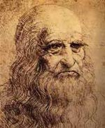1. Leonardo Da Vinci (1452–1519) Renaissance painter, scientist, inventor, and more. Da Vinci is one of most famous painters in the world for his iconic Mona Lisa and Last Supper.
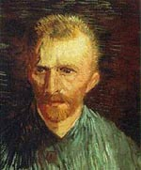2. Vincent Van Gogh (1853–1890). Dutch post-impressionist painter. Famous paintings include; Sunflowers, The Starry night, and Cafe Terrace at Night.
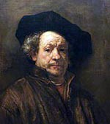3. Rembrandt (1606–1669) Dutch Master. One of the greatest painters, admired for his vivid realism. Famous paintings include The Jewish Bride and The Storm of the Sea of Galilee.
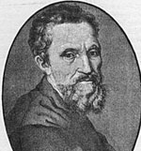4. Michelangelo (1475–1564) Renaissance sculptor, painter and architect. Famous paintings include his epic ceiling mural on the Sistine Chapel.
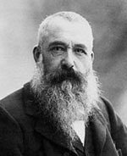5. Claude Monet (1840–1926) French impressionist painter. Famous paintings include Waterlilies, Women in Garden, and Impression Sunrise.
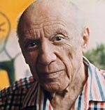6. Pablo Picasso (1881–1973) Spanish, modern ‘cubist’ painter. Famous works include Guernica and Bird of Peace.
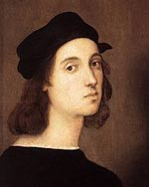7. Raphael (1483–1520) Italian painter. Raphael, da Vinci and Michelangelo make up the high Renaissance trinity. Famous paintings include Mond Crucifixion and The Wedding of the Virgin.
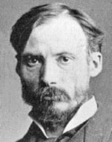8. August Renoir (1841–1919) French painter, one of the early pioneers of impressionism. Also influenced by Italian renaissance. Famous works include Dance at Le Moulin de la Galette and On the Terrace.
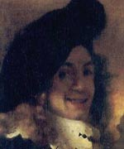9. Jan Vermeer (1632–1675) Dutch painter who specialised in genre painting – vivid depictions of still life. Famous paintings include View of Delft, Girl With a Pearl Earring, and The Milkmaid.
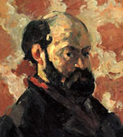10. Paul Cezanne (1839–1906) French post-impressionist painter. Famous paintings include; The Card Players and Still Life with a Curtain.
Listen and fill the information chart
William Turner, a great romantic English landscape painter, was born in Devonshire in 1775. He lived with his uncle in Middlesex, where he began to attend school. His first drawings are dated 1787, when he was only twelve years of age. His childish sketch-books, filled with drawings, are still presented in the British Museum.
When he was 21, he began to exhibit oil paintings as well as water-colours at the Royal Academy. The first “Fishermen at Sea” is now in the Gate Gallery.
He travelled much in France, Germany, Switzerland and Italy. But he never lost his interest in his own country.
As landscape painter Turner was interested mainly in light and colour effects. One of his famous paintings is even called “Light and Colour”. His work is highly praised by great critics.
Turner died in London in 1851. His pictures and drawings became the property of the British nation.
William Turner is considered to be one of the world greatest painters.first name – ………… last name – …………. nationality – ………… profession – ………… date of birth – ………. place of birth – …....... first drawings – …….. | at the age of 21 – …………………………… countries, which he visited – ……………….. critics’ opinion about his work – …………… famous paintings – …………………………. date of death – ……………………………… place of death – …………………………….. place where his paintings are kept – ………..
Find the missing parts of the sentences:
Claude Monet was the original founder and practitioner of …………….Some of his best known works include …………… .
Claude Monet was born on November 14, 1840 in Paris, France. His father was a grocery store owner and …………… . By the time he was fifteen Monet had become popular as …………… . In 1858 Monet met Eugène Boudin, a landscape painter who …………… .Boudin introduced Monet to outdoor painting, an activity that soon became his life's work.
Monet's studies were interrupted by …………… . In 1862 he entered the studio of Charles Gleyre in Paris. Claude Monet was interested in natural light, atmosphere, and color, and he tried ……………Monet exhibited regularly in the impressionist group shows, the first of which took place in 1874. On that occasion his painting Impression Sunrise …………… and the name stuck.
a) ………………… military service in Algeria.
b)…………………a caricaturist – a person who makes exaggerated portraits of people.
c)………………… “Impression Sunrise”, “Water Lilies”, and “Haystacks”.
d)………………… inspired a newspaper critic to call all the artists “impressionists”,
e)………………… became a great influence on the young artist.
f)………………… the French Impressionist movement in painting.
g)………………… to record them in his paintings as accurately as possible.
h)………………… his mother was a singer
Practical work 5. Performing art

Dance - Танець
Cinema –Кіно
Theater - Театр
Ballet – Балет
Concert – Концерт
Opera - Опера

MUSEUMS AND ART GALLERIES OF LONDON
London is very rich in museums and art galleries.
If you are fond of painting you'll go to the Tate Gallery. A rich sugar manufacturer Henry Tate founded it in 1897. There are about 300 oils and 19000 water-colours and drawings. There are many works by the English painter William Turner there. Most of his paintings are connected with the sea theme. There are a lot of paintings by the 16-th century English artists and paintings by foreign artists of the 19-20-th centuries. There are some paintings by impressionists there. You can see works by modern painters: Pablo Picasso among them. There are many interesting sculptures there. Henry Moor's can be seen there. He was a famous British sculptor. The National Gallery is one of the most important picture galleries in the world. The Tate Gallery is the most necessary compliment to the National Gallery as it contains contemporary works particularly by English and French masters.
The British Museum is the largest and richest of its kind in the world. It comprises the national museum of archaeology and ethnography and the national library. The present building was built in 1852. By law a copy of every book, periodical and newspaper, published in Britain must be presented in the British museum. It contains books and manuscripts: Greek, Roman, British and Oriental antiques. It has a department of Ethnography. This collection is so vast that only a very small percentage of it is on show to the public. There's also a department of prints and drawings. There're departments devoted to maps, coins, medals and philately. Those who come to the British museum can see a fascinating array of clocks and watches.
Cultural life of London would be impossible without the Royal Albert hall, the Royal Festival hall, the National theatre and a great number of museums: the Victoria and Albert museum, the Geological Museum, the Museum of Mankind, Natural history museum and others.
Match the words with their definitions:
1) a fame a) to show paintings, historical objects in a
public place
2) a scene b) is able to be used easily
3) a masterpiece c) a state of being known by a lot of people
4) a scenery c) a work of art that is of a very high quality
5) an exhibit d) an important event at which paintings are
shown
6) to display e) a view of a place as it appears in a picture
7) to be available f) mountains, forests, deserts, etc.
Listen the sentences and complete it with the words from the box:
devoted, prominent, frescos, inspired, icon-painting, scenery, portrait
- The early period in the development of painting in Ukraine referred to ___________.
- Numerous mosaics and ___________ in Kyiv Cathedral of St. Sophia were made following Byzantine traditions.
- ___________ painting was strongly influenced by the icon tradition.
- T. Shevchenko __________ his numerous portraits and landscapes to Ukraine.
- Landscapers of the 19th century depicted rural _________ in his works.
- Kazimir Malevich is a __________ representative of avant-garde in Ukrainian art of painting.
- ____________ by the beauty of Ukrainian natural scenery artists from Russia and European countries created their works of landscape painting
Answer:
- What is your favourite painting?
- Who is your favourite painter?
- Why do people go to museums and galleries?
- Do you often go to museums?
Look at the list of paintings.
Can you complete the names the artists who painted them?
1. Mona Lisa - L_______ d_______ V______
2. The Scream - E_______ M_______
3. Sunflowers - V_______ V_______ G_______
4. Guernica - P_______ P_______
5. Poppies in a Field - C_______ M_______

Practical work 6. Theatre

Actor- актор

Director- режисер

Scene- сцена

Costume- костюм
Make up – грим
Comedy- комедія
Tragedy – трагедія
THEATRE
We go to the theatre to see a play, that is to say, a performance given by actors and actresses. A play of a serious character, dealing with important human problems is called a tragedy. A play of a humorous, lighter character is a comedy (or a farce). Dramatists are called playwrights nowadays and there are no longer such great dramatists as Shakespeare or G. B. Show.
If we want to go to a theatre we buy tickets at the box-office and show them to the attendant at the entrance. In the building there is a hall, a large foyer and a cloak-room where we leave our overcoats, hats, etc. The audience can walk in the foyer in the intervals. Many doors lead to the auditorium consisting of stalls, boxes and balconies. In front of the auditorium there is a curtain separating it from the stage. The curtain rises when the play begins and falls at the end of each act.
Many people must work together to produce a play. The author writes it; the producer conducts the acting; carpenters, mechanics, designers prepare the scenery; electricians and light operators see to the light effects and operate the floodlights. We, the playgoers (or fans) demand an interesting plot, good acting, impressive scenery — that is two hours of good entertainment.

History of theatre
The point of departure for the European or Western history of theatre is the Greek theatre festivals in Athens in the 5th century B.C., where tragedies, comedies and satyr plays were performed before large audiences.
This tradition was continued in the Roman culture. In the Middle Ages another form of theatre emerged, connected to the Church and Christianity, but there were also secular comedies and performances by jugglers. The theatre of the Renaissance and Baroque periods was inspired by the drama of antiquity, while in the Romantic Movement themes were taken from medieval history and myths. With realism at the end of the 1800s, contemporary problems were taken up for debate, but already at the beginning of the 1900s came reactions to realism with movements such as symbolism, expressionism and absurdism.
Present-day theatre is characterised by great diversity, in which older and newer forms exist side by side, often in untraditional interpretations and expressions. Research in history of theatre embraces many forms of theatre and deals with a broad concept of theatre without sharp boundaries between other cultural events which contain elements of performance and staging.
Theatre performances and theatrical events of the past are explored both with a focus on aesthetic means and artistic expression and in relation to social, cultural, economic and political conditions in the contemporary historical period. Research in history of theatre may also include studies of performers and professions within the theatre, such as actors and the art of acting, directors and the art of directing, scenographers and scenography.

Practical work 7. Music
Listen to music- слухати музику
Recorder- плеєр
Singer- співак
Producer- продюсер
Stage – сцена
Star- зірка
Popostar- поп зірка
Concert- коннцерт
Microphone- мікрофон
Musics school- музична школа
To play - грати

Music
Can you think of a day without music? We can hear music everywhere: in the streets and at home, over the radio and on TV, in the shops and in the parks. People all over the world are fond of music. They listen to music, they dance to music, they learn to play musical instruments.
But what is music? Specialists explain that music isn't only a combination of pleasant sounds. It is an art which reflects life. There are a lot of different kinds of music. Some of them appeared long ago, and some are modern. For example, folk music appeared long ago, but it is still alive. There are many local performers, choirs and folk groups in Russia; but perhaps the most famous singer is Nadezhda Babkina. Folk songs are very tuneful and pleasant to listen to. Classical music is often associated with the music of the past. However, this style also includes music being written now, and we may speak of modern classical music. Rap is a modern musical style where the singer speaks or shouts the words in time to music with a steady beat. Such groups as Public Enemy or House of Pain are leaders in this style.
Great Britain has produced more popular music stars than any other country. Over the last 30 years rock and pop music have been very popular in Britain. The Beatles, with their style of singing, eloquent and exciting, is still one of the most popular groups. British groups often set new trends in music. New styles, groups and singers continue to appear. Some of the more recent pop groups are Dire Straits, Eurhythmics and Spice Girls. Many of the new bands have been able to use the changes in technology to develop their music. Computerized drum machines, synthesizers and other electronic instruments are now just as popular as the piano and electric guitars.
Tastes differ. So people's musical interests range from pop and rock music, which are extremely popular nowadays, especially among young people, to classical music and opera.
My favourite style of music is pop music, because it is breathtaking and full of energy. When I listen to pop music it makes me remember happy times and forget the problems of everyday life. It helps me to relax when I'm tired, and entertains me when I'd like to have fun. My favourite group is Abba. It was formed in 1973 in Sweden. Abba's cheerful tunes made them international pop stars and one of the most successful groups of the seventies. Their most famous songs ("Waterloo", "Money, Money, Money", "Knowing Me, Knowing You", etc.) often topped European charts. Though the group doesn't exist any more, it is still popular with people of all ages. I can't but admire their style of singing. I find it fascinating and overwhelming. When I have free time I listen to their records. I also like having background music while I am working.
I don't mind listening to dance music, especially when I go to disco clubs. This style of music is catchy and I like catchy tunes. It makes me more energetic.
It's a pity that many young people like to listen only to modern music. As for me, I also enjoy listening to classical music. I find it tuneful and appealing. Classical music is always a complex of emotions. It gives me delight, pleasure and a sense of happiness. Some pieces of classical music are really wonderful. Not long ago I listened to the First Piano Concerto, composed by Tchaikovsky. The power of his music captivated me. The impression was overwhelming.
The music I hate is heavy metal. I find it noisy and dreadful. When I listen to this style of music it presents to my mind pictures of dark days. Though some young people are fond of this style of music, it is not to everyone's taste. To my mind, music too loud can destroy our ears. I am indifferent to other styles of music. For example, I don't mind listening to jazz. Improvisation is an important part of this style, that's why a jazz song may sound a little different each time it is played. I think that jazz is a mixture of many different kinds of music, but I consider it a bit complicated.
My mother and father approve of my tastes in music. Though they prefer to listen to classical and "bard music", they think that, on the whole, modern music is not too bad. My parents agree that each generation has its own tastes.
It goes without saying that music plays a very important role in people's lives. It reflects our moods and emotions. Music appeals to our hearts and transforms our feelings. It conquers our souls and enriches our minds. Besides, listening to music is the perfect way to spend free time and not to feel bored. You can hardly find a person who doesn't like or need music and who never sings or dances. Music is beauty in sounds; it is our magic source of inspiration.
Answer:
- Which styles of music do you know?
- Personally you prefer which music?
THE TOP 8 GENRES IN THE MUSIC INDUSTRY CURRENTLY :
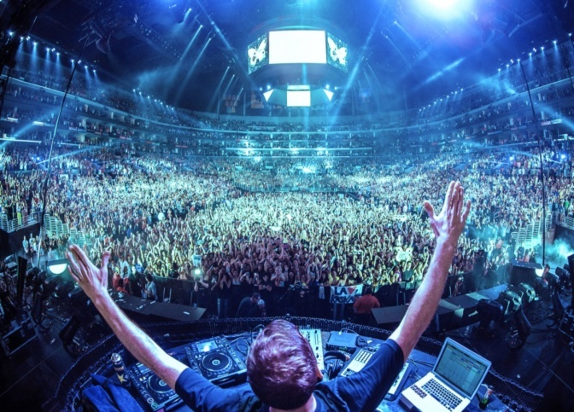1.Electronic Dance Music:
Generally referred as EDM, this form of music is produced by DJs who add dozens of tones to a piece to create unique music. You can hear them in clubs or even live, depending upon your accessibility for the same. In the early twenties, electronic dance music was known in the form of Jamaican dub music, the electronic music of Kraftwerk, the disco music of Giorgio Moroder, the Yellow Magic Orchestra and many more.
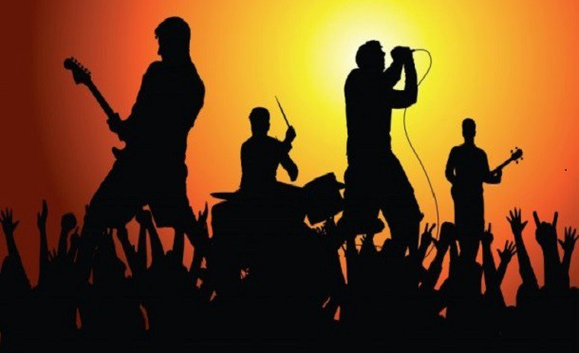2. Rock Music:
Originated as “Rock & Roll” in the United States, Rock music has been rocking the world since the 1950s. It is a form of music that started actually around string instruments, but now uses other modern instruments too making it a little difficult to give it an accurate definition. Its loud and strong beats make it popular among the youths. Some of the rock stars who have popularized the culture include Little Richard, Bill Haley and Chuck Berry while rock bands like Pink Floyd, The Doors, Metallica, Nirvana and Megadeth are the modern bands who have taken the culture by storm.
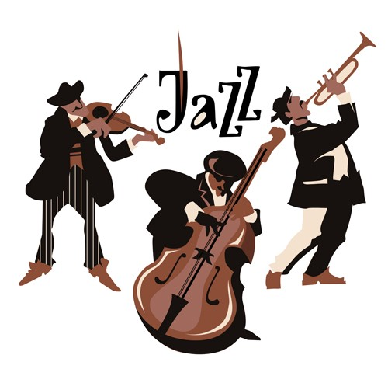3. Jazz:
Identified with swing and blue notes, Jazz has its roots both in the West African and European culture. It is said that Jazz is “One of America’s original art forms” and boasts a unique combination of creativity, coactions and interactivity. Originating in the late 19th to early 20th century, Jazz has also played an important role in introducing the world to a number of women performers like Ella Fitzgerald, Betty Carter, Abbey Lincoln and Ethel Waters.
4. Dubstep:
The use of instruments attracting music lovers for its bass and rhythm, this falls in the electronic music genre. People consider it to be a darker form of music, but since its birth in the late 1990s, this genre has successfully made its place in the industry.
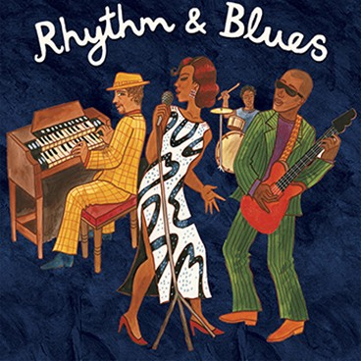5. Rhythm and Blues:
Vocalists like Rihanna, Mariah Carey, Beyoncé, Usher and the legendary Michael Jackson have all made it huge in the music industry with their love for this form of music. Originated in the 1940s, this African-American music is a combination of hip hop, funk, dance, pop and soul focusing on themes like relationships, sex and freedom.
6. Techno:
You may have listened to a number of techno music while clubbing, but it is Detroit techno that is considered to be the foundation of this form of music. Unlike the days of its emergence, the use of technology today has greatly enhanced the quality of techno style music and popularizing it among people day by day.
7. Electro:
A perfect blend of hip hop and electronic music, electro or electro-funk uses drum machine, vocoder and talkbox helping it to distinguish itself from another similar form of music, Disco. Notable artistswho have been into this form of music include Arthur Baker, Freeez, Man Parrish and Midnight Star.
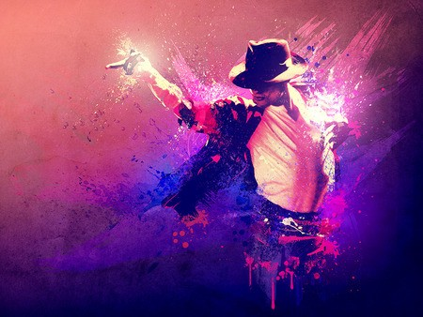8. Pop Music:
“Pop” is a term derived from “Popular” and thus Pop Music is known to be a genre of popular music. With its roots in the rock & roll style, this form can include any form of music ranging from urban and dance to rock, country and Latin. Instruments highly used are electric guitars, synthesizer drums as well as bass and one can listen to this form of music by listening to songs by Britney Spears, Madonna, Beyonce Lady Gaga and of course the “King of Pop”, Michael Jackson.

Practical work 8. Modern art

STREET ART 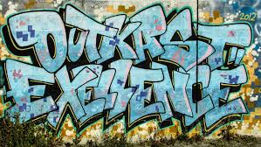
New Yorkers used to see the graffiti on the walls of poor neighbourhoods and subway trains as something menacing and an example of urban decay. The scrawled names and slogans were seen as unsightly and aggressive, the work of vandals seeking to express their identities or even make a political point. Up to the 1970s, most New Yorkers hated graffiti, considering it as an eyesore that was illegal and punishable by fines.
Since those days, graffiti has changed a lot and it is no longer found only in the subway and the poor ghetto areas of the city. Nowadays, it has the status of 'street art' and you get graffiti in places where you wouldn't expect to - in advertisements, on clothes, on toys, and even on the Wall Street Journal's official website! In the early 1980s, there was a real craze for graffiti art and the sophisticated Manhattan art world had displays of street art in its galleries. The trend was short-lived - until the arrival of hip-hop music in the late 80s.
In her book, Subway Art, Martha Cooper says "Graffiti came back with hip-hop music and people are now appreciating it for its style, which they couldn't back then, because they couldn't get beyond the vandalism thing." Hip-hop was originally black ghetto music, sung by young African Americans from the poor, run-down districts of American cities. When it suddenly got to the top of the American music charts, hip-hop culture was spread, bringing graffiti with it.
Today companies are starting to realise the appeal of graffiti in advertising. Kel Rodriguez, who used to spray New York subway trains, was the artist chosen to design the Wall Street Journal's website and it is obviously done in graffiti-style. "Some of that graffiti feeling, that energy, sort of got in there," Rodriguez explained. Many of this new wave of artists give lectures on developments in their art. Lee Quindnesis having a lot of success in Europe and feels that European galleries and museums are more open to his art form. "They want to support an artist as he develops," comments Quinones, who can get up to $10,000 for his paintings. Indeed, the Groninger Museum in Holland is one of the few museums in the world that displays and recognizes graffiti as an art form.
Another artist, Blade, has his own website devoted only to the world of graffiti. This website has a 'merchandise page' where Blade sells things with his own original designs all over the world - everything from baseball caps to yo-yos! Leonard McGurr, a street artist for 25 years, went from painting subway trains to designing and marketing graffiti-inspired clothes for young people. "Graffiti has been a story of survival," he says. "There's a way to benefit from your work without spoiling public property."
Circle for or against:
1Graffiti is a way for people to express their ideas and feelings. for against
2. It is a waste of money cleaning it up. for against
3. Graffiti ruins public areas and makes children afraid to play in parks. for against
4. Graffiti makes a town look more attractive. for against
5. Why should one person decide what public property looks like? for against
6. Museums and art galleries now include graffiti in their collections. for against
7. Graffiti is art. for against
8. Graffiti is vandalism. for against
Practical work 9. Written Art
Literature- Література
Novels -Новели
Drama- Драма
Short Story- Історія
Biography / Autobiography- Біографія
Poetry- Поезія
BRITISH LITERATURE
Great Britain gave the world a lot of talented people. Many famous writers and poets were born and lived in Great Britain.One of the best known English playwrights was William Shakespeare. He draw ideas for his tragedies and comedies from the history of England and ancient Rome. Many experts consider Shakespeare the greatest writer and the greatest playwright in English language. William Shakespeare wrote 37 plays which may be divided into: comedies (such as "A Midsummer Night's Dream"), tragedies (such as "Hamlet", "Othello", "King Lear", "Macbeth") and historical plays (such as "Richard II", "Henry V, "Julius Caesar", "Antony and Cleopatra").
Robert Burns represents the generation of Romantic writers. In his poems he described with love and understanding' the simple life he knew. Among his well-known poems are "Halloween", "The Jolly Beggars", "To a Mouse".
Lord George Gordon Byron. His free-spirited life style combined with his rare poetic gift makes him one of the most famous figures of the Romantic Era. His famous works such as "Stanzas to Augusta", "The Prisoner of Chillon", "Childe Harold's Pilgrimage", "Manfred" draw readers into the passion, humors and conviction of a poet whose life and work truly embodied the Romantic spirit.
Sir Walter Scott wrote the first examples of historical novel, for instance, "Ivanhoe".
Lewis Carroll became famous when he published "Alice's Adventures in Wonderland"
Fill the gaps, chosing words below:
The old man, well-known, battle, Ernest Hemingway, fisherman, "The Old Man and the Sea" .
My favourite book is "The Old Man and the Sea" by ….This story is one of the … works of the writer. The author depicts the characters of the old man and the boy and their relations very vividly and skillfully. Santiago, the old man, was one of the writer's beloved characters. The old man was a born …, but he was not a butcher and fished only for a living. He was very lonely. He had a devoted friend - the boy, Manolin. The boy loved the old man for his kind heart, his devotion to the sea. Manolin was like a son to Santiago. He took care of the old man's food and his belongings. …. was glad to pass his experience to the boy. He looked forward to going to the sea together with the boy. All Santiago's life had been in preparation for the battle with big fish. He knew that he had been born for this and it was time to prove it. A strong man at last had met a strong fish. The … was a difficult one and full of danger. Though the sharks had eaten the fish and nothing had left but the backbone, the old man had morally won the battle. Santiago's words "man can be destroyed but not defeated" are the main idea of this story. ….is a masterpiece for its imaginative language and the description of nature.

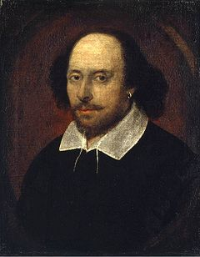

WILLIAM SHAKESPEARE
William Shakespeare (1564-1616). English poet and playwright – Shakespeare is widely considered to be the greatest writer in the English language. He wrote 38 plays and 154 sonnets.
Short biography of William Shakespeare
William Shakespeare was born in Stratford-upon-Avon on 23rd April 1564.
His father William was a successful local businessman, and his mother Mary was the daughter of a landowner. Relatively prosperous, it is likely the family paid for Williams education, although there is no evidence he attended university.
In 1582 William, aged only 18, married an older woman named Anne Hathaway. They had three children, Susanna, Hamnet and Juliet. Their only son Hamnet died aged just 11.
After his marriage, information about the life of Shakespeare is sketchy, but it seems he spent most of his time in London – writing and acting in his plays.
Due to some well-timed investments, Shakespeare was able to secure a firm financial background, leaving time for writing and acting. The best of these investments was buying some real estate near Stratford in 1605, which soon doubled in value.
It seemed Shakespeare didn’t mind being absent from his family – he only returned home during Lent when all the theatres were closed. It is thought that during the 1590s he wrote the majority of his sonnets. This was a time of prolific writing and his plays developed a good deal of interest and controversy. His early plays were mainly comedies (e.g. Much Ado about Nothing, A Midsummer’s Night Dream) and histories (e.g. Henry V)
By the early Seventeenth Century, Shakespeare had begun to write plays in the genre of tragedy. These plays, such as Hamlet, Othello and King Lear, often hinge on some fatal error or flaw in the lead character and provide fascinating insights into the darker aspects of human nature. These later plays are considered Shakespeare’s finest achievements.
Some academics, known as the “Oxfords,” claim that Shakespeare never actually wrote any plays. They contend Shakespeare was actually just a successful businessman, and for authorship suggest names such as Edward de Vere. Nevertheless, there is evidence of Shakespeare in theatres as he received a variety of criticism from people such as Ben Johnson and Robert Greene. When writing an introduction to Shakespeare’s First Folio of published plays in 1623, Johnson wrote of Shakespeare:
“not of an age, but for all time”

Shakespeare the Poet
William Shakespeare wrote 154 sonnets mostly in the 1590s. These short poems, deal with issues such as lost love. His sonnets have an enduring appeal due to his formidable skill with language and words.
“Let me not to the marriage of true minds
Admit impediments. Love is not love
Which alters when it alteration finds,
Or bends with the remover to remove:”
– Sonnet CXVI

The Plays of Shakespeare
The plays of Shakespeare have been studied more than any other writing in the English language and have been translated into numerous languages. He was rare as a play-write for excelling in tragedies, comedies and histories. He deftly combined popular entertainment with an extraordinary poetic capacity for expression which is almost mantric in quality.
“This above all: to thine ownself be true,
And it must follow, as the night the day,
Thou canst not then be false to any man.
Farewell: my blessing season this in thee!”
– Lord Polonius, Hamlet Act I, Scene 3
During his lifetime, Shakespeare was not without controversy, but he also received lavish praise for his plays which were very popular and commercially successful.
His plays have retained an enduring appeal throughout history and the world. Some of his most popular plays include:
- Twelfth Night
- Henry V
- Romeo and Juliet
- Macbeth
- Hamlet
- King Lear
- Othello
Answer:

- Which poets do you know?
- Prepare project of different authors and their works.
- Write an essay concerning your attitude to books.
- Explain how poetry can affect your life.

1. Arts improves your creativity skills.
Whether it is cooking, painting or music, we do art as if its our own.

2. Arts gives you joy.
I smile whenever I sing my favorite song. Any kind of art can give you so much happiness.

3. Arts relieves stress.
Don't you go to another world when you just sing or listen to a favourite tune?

4. Arts gives you the opportunity to showcase your talent.
Even words doesn't give that much opportunity like art does. By showing our talent, we show that there is something special about us.

5. Arts gives you confidence.
When I sing or perform, I feel so good about myself. I feel there are no worries, hence I perform confidently.

6. Arts helps you do well academically.
Trust me, just a few hours of art will help you relieve stress and give you happiness. With that your mind will be clear, and that would help you focus on your studies, and that would help you get good grades. If you don't do art for few hours, your mind would be stressed and you wouldn't be able to focus and do well.

7. Arts helps you to communicate with other people.
I connect with people through music. I have met most of my friends because of music.

8. Arts helps you learn visually
Thanks to art, I have become a visual learner. Learning Visually helped me a lot in studies.

9. Arts helps you to express your emotions
I use singing to showcase my emotions, whether I am happy, sad or angry. And above all...

10. Art is a different language
Art says things that even words cannot say. You don't need a language to understand Art. Just a small painting, or a food item, or improvising a tune or a step, can express a lot of things without words.
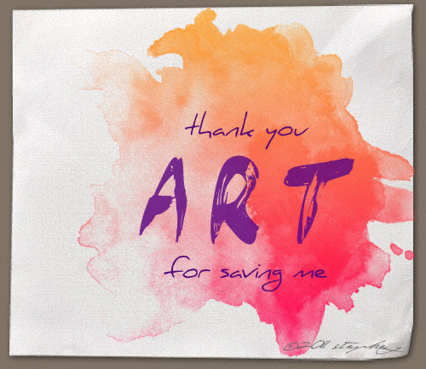

СПИСОК ВИКОРИСТАНИХ ДЖЕРЕЛ
- Англійська мова: Підручник для 9-го класу загальноосвітніх
навчальних закладів. - Тернопіль: Астон, 2017. - 288 c.
- Англійська мова 11 клас. / Калініна Л. В., Самойлюкевич І. В.
Київ: Наш час, 2011 [Електронний ресурс] - Режим доступу: https://vshkole.com
- Англо-український і україно-англійський словник [Електронний ресурс]– Режим доступу : https//: www:multitran.ru
- Курс вивчення англійської мови [Електронний ресурс] – Режим доступу : https://learnenglish.britishcouncil.org
- Литвитнов Ю.Яскрава англійська мова / Т.: Вид-во «Нова книга», 2016. – 350 c.
- Розмовний курс англійської [Електронний ресурс] – Режим доступу:https://greencountry.com.ua.
- "Природные катастрофы, стихийные бедствия" [Електронний ресурс]-Режим доступу :https://s-english.ru/topics/natural-disasters
- Evans V., Dooley J. Enterprise 1: Coursebook. Express Publishing, 2015
[Електронний ресурс] - Режим доступу: https://testlib.meta.ua
- Longman Dictionary of Contemporary English [Електронний ресурс]
Режим доступу : https:// www.longman.com
- Solutions: Intermediate Workbook. / Jane Hudson, Tim Falla, Paul Devies – Oxford University Press, 2016. – 126 p.
- Solutions: Intermediate Student’s book. / Tim Falla, Paul Devies – Oxford University Press, 2016. – 139 p.
- On Screen : Student’s book, B1/ Dooley Jenny, Evans Virginia –
Express Publishing, 2015 – 212 p.
- Project English 3/ Tom Hutchinson – Oxford University Press, 2017. –120 p.

NOTES
_________________________________________________________________________________________________________________________________________________________________________________________________________________________________________________________________________________________________________________________________________________________________________________________________________________________________________________________________________________________________________________________________________________________________________________________________________________________________________________________________________________________________________________________________________________________________________________________________________________________________________________________________________________________________________________________________________________________________________________________________________________________________________________________________________________________________________________________________________________________________________________________________________________________________________________________________________________________________________________________________________________________________________________________________________________________________________________________________________________________________________________________________________________________________________________________________________________________________________________________________________________________________________________________________________________________________________________________________________________________________________________________________________________________________________________________________________

Іноземна мова: методичні вказівки до виконання практичних робіт для здобувачів вищої освіти, освітньо-професійної програми «Менеджмент», галузі знань 07 Управління та адміністрування, спеціальності 073 Менеджмент, денної форми навчання / уклад. І.М.Лавринюк. – Луцьк: ТК Луцького НТУ, 2019.– 54 c .

Комп’ютерний набір І.М. Лавринюк
Редактор І. М. Лавринюк

Підп. до друку« » 2019 року. Формат 60x84/16. Папір офс.
Гарн. Таймс . Ум.друк. арк.. 3.37
Тираж 50 примірників

Інформаційно-видавничий відділ
Луцького національного технічного університету
43018, м. Луцьк, вул. Львівська, 75
Друк – ІВВ Луцького НТУ

